Analysis of Iris Flower

Contents

Investigations into Iris flower 2

Objectives 2

Summary of each variable of Fisher's *Iris* Data 2

Histograms 2

Data Exploration 2

Scatterplots 6

Data Exploration 6

References 8

# Investigations into Iris flower

## Objectives

* **Explore differences in petal width and length**
* **Identify relationships**

**Imported data**

The following was imported into my program on the command, panda as it has easy to use data structures and data analysis, numpy as is a good python package and matplotlib and seaborn to assist drawing plots.

import numpy as np

import matplotlib.py as plt

import seaborn as sns

import pandas as pd

# Summary of each variable of Fisher's *Iris* Data

150 plants, three species with 50 setosa, 50 versicolor and 50 virginica

Irish Data Summary

## Histograms

### Data Exploration

Average length and width of each flower;

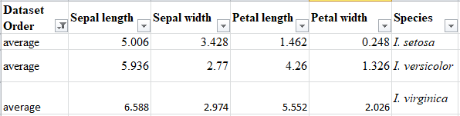

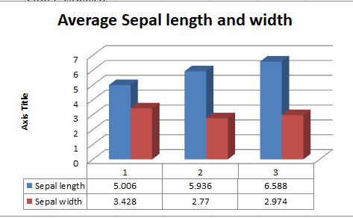

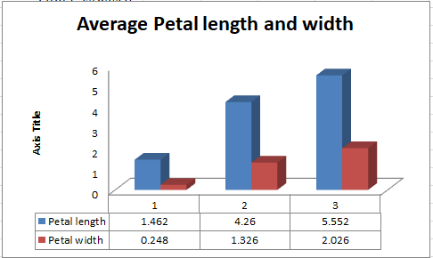

Min;

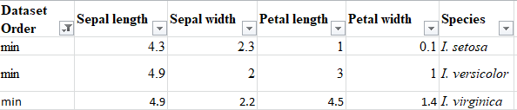

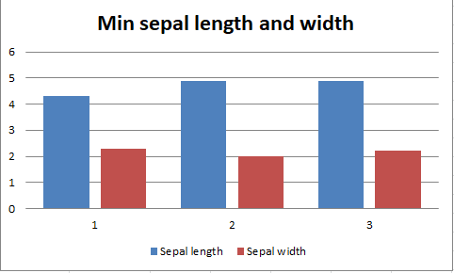

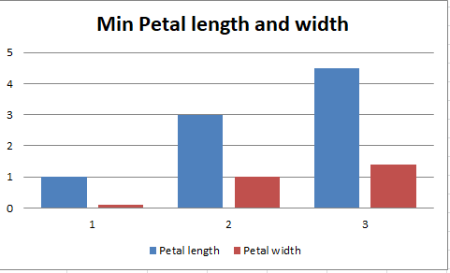

Max

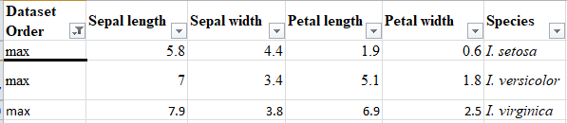

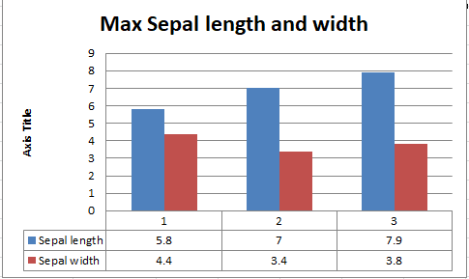

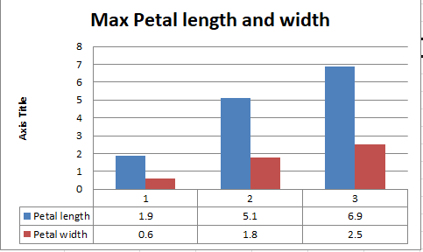

## Scatterplots

### Data Exploration

A view of the Iris Flower’s petal length versus the petal width

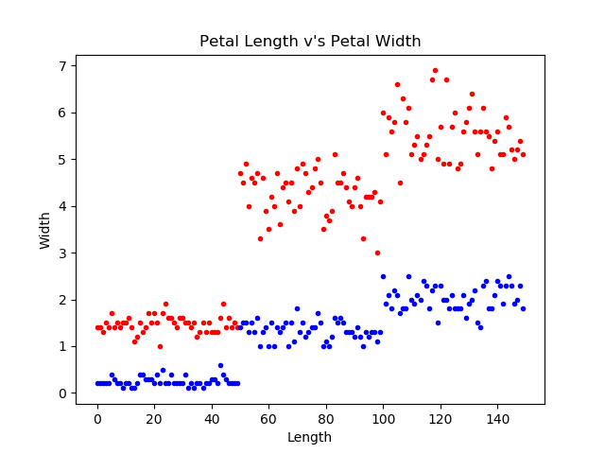

A view of the Irish Flower’s sepal length versus sepal width

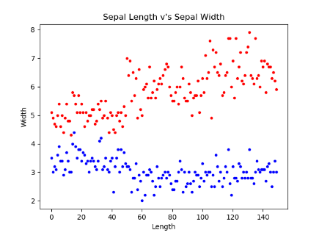

Various statistics regarding the Iris flowers

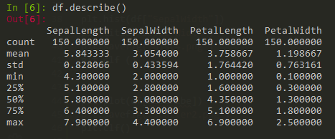

# References

<https://en.wikipedia.org/wiki/Iris_flower_data_set>

<https://medium.com/codebagng/basic-analysis-of-the-iris-data-set-using-python-2995618a6342>

<https://scikit-learn.org/stable/auto_examples/datasets/plot_iris_dataset.html>

<https://www.ritchieng.com/machine-learning-iris-dataset/>

<https://raw.githubusercontent.com/pandas-dev/pandas/master/pandas/tests/data/iris.csv>

<https://www.datacamp.com/community/tutorials/seaborn-python-tutorial?utm_source=adwords_ppc&utm_campaignid=9942305733&utm_adgroupid=100189364546&utm_device=c&utm_keyword=&utm_matchtype=b&utm_network=g&utm_adpostion=&utm_creative=229765585186&utm_targetid=aud-392016246653:dsa-929501846124&utm_loc_interest_ms=&utm_loc_physical_ms=9047196&gclid=Cj0KCQjwhZr1BRCLARIsALjRVQMajLmSDYQKT6ibFmT-F-N_1aQjcS9lhZEnpYbbwsT0wWDkY23Rj6waAjzbEALw_wcB>